**Tableau Module 21 to 23**

Create Dual Axis Charts:

1. Dual axis are two independent axes that are layered on top of each other.
2. Dual axes allow you to compare multiple measures.
3. Dual axes are useful when you have two measures that have different scales.
4. To add a measure as a dual axis:
5. Drag the field to the right side of the view and drop it when you see a black dashed line appear.
6. You can also right-click (control-click on Mac) the measure on the Columns of Tows shelf and select Dual Axis

# **Add Axes for Multiple Measures in Views**

There are several different ways to compare multiple measures in a single view. You can:

* Create individual axes for each measure.
* Blend two measures to share an axis.
* Add dual axes where there are two independent axes layered in the same pane.

In any of these cases you can customize the marks for each axis to use multiple mark types and add different levels of detail. Views that have customized marks are called combination or combo charts.

Add individual axes for measures

To add individual axes for each measure, drag measures to the **Rows** and **Columns** shelves.

* Adding a continuous field on the Rows shelf adds an additional axis to the rows of the table.
* Adding a continuous field on the Columns shelf adds an additional axis to the columns of the table.

The example below shows quarterly sales and profit. The Sales and Profit axes are individual rows in the table and have independent scales.

The Order Date field on the Columns shelf is a discrete date dimension. Because it is discrete, it creates headers rather than an axis.

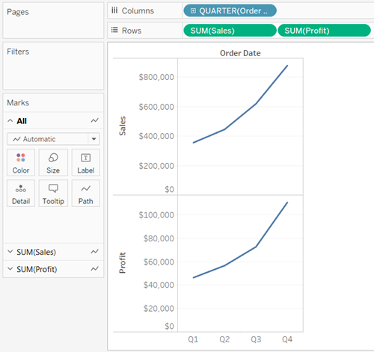

Blend axes for multiple measures into a single axis

Measures can share a single axis so that all the marks are shown in a single pane.

To blend multiple measures, drag one measure or axis and drop it onto an existing axis.



Instead of adding rows and columns to the view, when you blend measures there is a single row or column and all of the values for each measure is shown along one continuous axis. For example, the view below shows quarterly sales and profit on a shared axis.

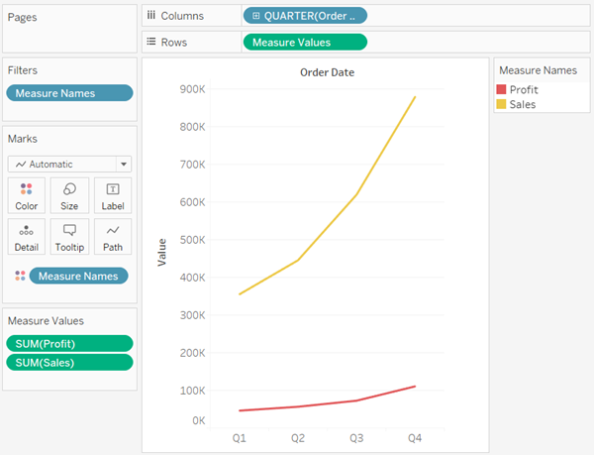

Blending measures uses the **Measure Names** and **Measure Values** fields, which are generated fields that contain all of the measure names in your data source and all of the measure values. The shared axis is created using the **Measure Values** field. The **Measure Names** field is added to **Color**on the Marks card so that a line is drawn for each measure. Finally, the **Measure Names** field is filtered to only include the measures you want to blend.

**Note:** Blending axes is most appropriate when comparing measures that have a similar scale and units. If the scales of the two measures are drastically different, the trends may be distorted.

Compare two measures using dual axes

You can compare multiple measures using dual axes, which are two independent axes that are layered on top of each other. Dual axes are useful for analyzing two measures with different scales.

To add a measure as a dual axis, drag the field to the right side of the view and drop it when you see a black dashed line appear.

You can also right-click (control-click on Mac) the measure on the Columns or Rows shelf and select **Dual Axis**.



The result is a dual axis view where the Profit axis corresponds to the blue line and the Sales axis corresponds to the orange line.

You can add up to four layered axes: two on the Columns shelf and two on the Rows shelf.

## Synchronize axes to use the same scale

To align the two axes in a dual axes chart to use the same scale, right-click (control-click on Mac) the secondary axis, and select **Synchronize Axis**. This aligns the scale of the secondary axis to the scale of the primary axis.

In this example, the Sales axis is the secondary axis and the Profit axis is the primary axis.

**Note:** To synchronize axes, the data types for both measures must be the same. If the data types for your measures are different, see the section below.  
  
You can synchronize dual axes for numeric data types that don't match. For example, you can synchronize an axis that uses an integer data type and an axis that uses decimal data type.

If you would like to change which axis is the primary, and which axis is the secondary, select the field on the Columns or Rows shelf that is the secondary, and drag it in front of the primary field on the shelf until you see an orange triangle appear.

In this example, you can select the **SUM(Sales)** field on the **Rows**shelf, and drag it in front of the **SUM(Profit)** field. The Sales axis is now the primary and the Profit axis is the secondary.

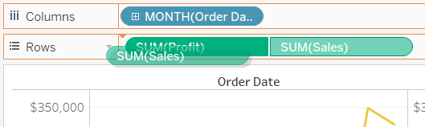

## Synchronize axes with measures of different data types

The **Synchronize Axis** option ensures that you make a scaled and correct comparison in a dual axes chart. However, sometimes this option may not be available (grayed out). This is because the data type of one of the axes is different from the other.

**Note**: In a chart with dual axes, starting with version 2018.1, you can synchronize dual axes for numeric data types that don't match. For example, you can synchronize an axis that uses an integer data type and an axis that uses decimal data type.

To resolve this issue, you must change the data type of one of the axes. Follow the example below to change the data type for an axis.

1. Click the new Worksheet  icon to open a new worksheet.
2. Drag **Order Date** to Columns, then click the drop-down arrow on the field on the shelf and select **Month**from the context menu.
3. Drag **Sales** to Rows, then drag **Quantity** to the right side of the view and drop it when you see a black dashed line appear to create a dual axis.

If you right-click on the **Quantity** Axis, you can see that the **Synchronize Axis** option is grayed out

1. In the Data pane, click on the drop-down arrow on the **Quantity** field, and select **Change Data Type** > **Number (decimal)** in the context menu. This changes the data type for this field.

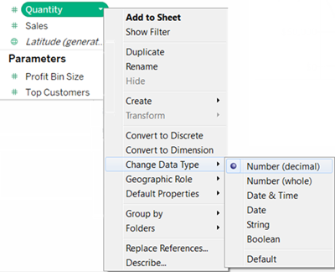

1. Replace the **Quantity** measure on the view.
2. Right-click the secondary axis, and then select **Synchronize Axis**.

## Customize the marks for a measure

1. Select the Marks card for the measure that you want to customize. There is a Marks card for each measure on the Rows and Columns shelves.

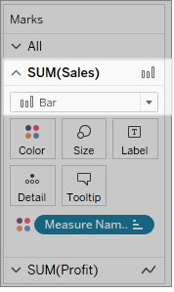

1. Select a new mark type for the measure.



Any changes to the mark type, shape, size, color, detail and other mark properties will be applied to the selected measure.

For example, in the view below the **Sales** Marks card is active. The Mark Type has been changed to **Bar**and when **Product Type**is placed on **Color**on the**Sales** Marks card, the encoding and level of detail is only applied to the Sales marks. The Budget Sales mark is not broken down by Product Type.

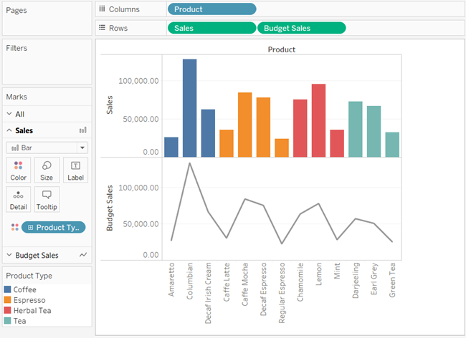

### **Tips**

* Select a field in the Marks card to modify only its properties.
* Select the **All** Marks card to modify properties for all measures at once.
* To change the order of a field's marks in the view, right-click its axis, and then select **Move marks to front**.

## Create a combo chart (assign different mark types to measures)

When working with multiple measures in a view, you can customize the mark type for each distinct measure. Because each measure can have customized marks, you can customize the level of detail, size, shape, and color encoding for each measure too.

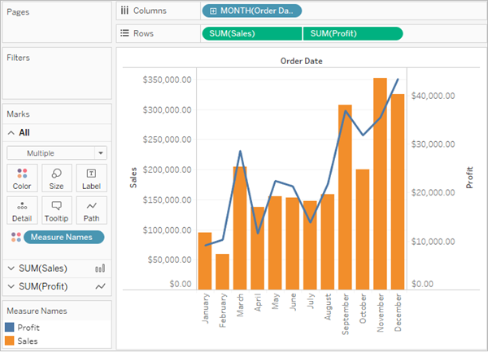

For example, you could create a view that uses two measures in dual axes. One measure shows Profit with a line mark, and the other measure shows Sales with bar marks. You could also choose to display the measures as individual axes or blended axes.

**To create a combo chart like this example**

1. Connect to the Sample - Superstore data source.
2. Drag the Order Date measure to the Columns shelf, and then click Order Date change Year to Month.



1. Drag the Sales measure to the Rows shelf.



1. Drag the Profit measure to the right side of the view and drop it when you see a black dashed line appear.



1. Click the Sales card. Change the Sales mark type to **Bar**.



**Optional**: To adjust the colors used for the Sales and Profit marks:

* 1. Click the **All** card, click **Color**, and then click **Edit Colors**.
  2. Click the Profit data item, and then click a different color in the palette. Click the Sales data item, and then click a different color in the palette.
  3. Click **Apply**, and then click **OK**.

Aggregation, Granularity, and Level Of Detail

Aggregation:

1. In Data Aggregation in Tableau, values of multiple rows are grouped together as the input to form a single value of more significant meaning, such as a set or list.
2. Whenever you add a measure to you view, an aggregation is applied to that measure by default. The type of aggregation applied varies depending on the context of the view.
3. For example, Sales become SUM(Sales).

Granularity:

It basically means breaking down into small pieces.

This is basically done using Dimensions.

1. Level of Detail:

This functionality is somewhat similar to colors option under Marks Card.

It helps differentiate graphs Based on some fields.

# **Data Aggregation in Tableau**

In Tableau, you can aggregate measures or dimensions, though it is more common to aggregate measures. Whenever you add a measure to your view, an aggregation is applied to that measure by default. The type of aggregation applied varies depending on the context of the view.

## Change the Aggregation of a Measure in the View

When you add a measure to the view, Tableau automatically aggregates its values. Sum, average, and median are common aggregations;

The current aggregation appears as part of the measure's name in the view. For example, **Sales** becomes **SUM(Sales)**. Every measure has a default aggregation which is set by Tableau when you connect to a data source. You can view or change the default aggregation for a measure—

You can aggregate measures using Tableau only for relational data sources. Multidimensional data sources contain data that is already aggregated. In Tableau, multidimensional data sources are supported only in Windows.

You can change the aggregation for a measure in the view from its context menu:

A graphic depicting how to change the aggregation of a measure
using the field’s context menu.

## Aggregating Dimensions

You can aggregate a dimension in the view as **Minimum**, **Maximum**, **Count**, or **Count (Distinct)**. When you aggregate a dimension, you create a new temporary measure column, so the dimension actually takes on the characteristics of a measure.

A graphic depicting how to
aggregate a dimension using the options in the field’s context menu.

**Note**: The **Count (Distinct)** aggregation is not supported for Microsoft Access data sources, and for Microsoft Excel and Text File data sources using the legacy connection. If you are connected to one of these types of data sources, the **Count (Distinct)** aggregation is unavailable and shows the remark "Requires extract." If you save the data source as an extract, you will be able to use the **Count (Distinct)** aggregation.

Another way to view a dimension is to treat it as an Attribute. Do this by choosing **Attribute**from the context menu for the dimension. The **Attribute** aggregation has several uses:

* It can ensure a consistent level of detail when blending multiple data sources.
* It can provide a way to aggregate dimensions when computing table calculations, which require an aggregate expression.
* It can improve query performance because it is computed locally.

Tableau computes Attribute using the following formula:

IF MIN([dimension]) = MAX([dimension]) THEN MIN([dimension]) ELSE "*" END

The formula is computed in Tableau after the data is retrieved from the initial query. The asterisk (*) is actually a visual indicator of a special type of Null value that occurs when there are multiple values.

Below is an example of using Attribute in a table calculation. The table shows sales by market, market size, and state. Suppose you wanted to compute the percent of total sales each state contributed to the market. When you add a Percent of Total quick table calc that computes along State, the calculation computes within the red area shown below. This is because the Market Size dimension is partitioning the data.

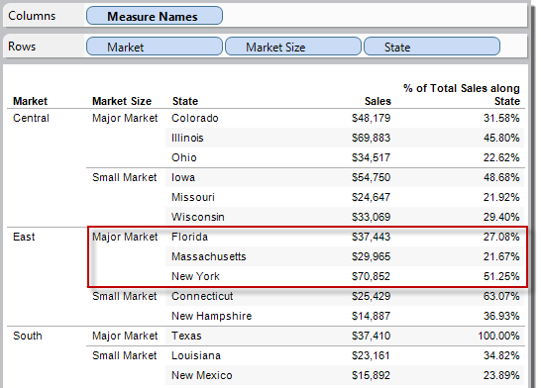

When you aggregate Market Size as an Attribute, the calculation is computed within the Market (East, in the following image), and the Market Size information is used purely as a label in the display.

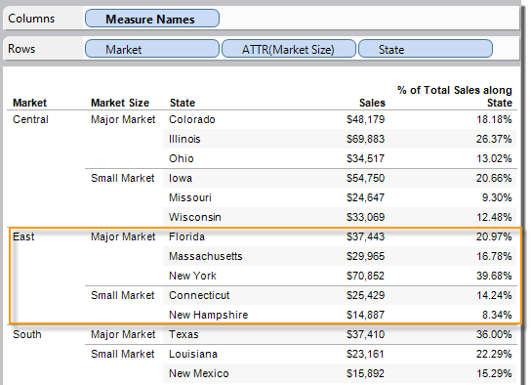

## List of Predefined Aggregations in Tableau

Sometimes it is useful to look at numerical data in an aggregated form such as a summation or an average. The mathematical functions that produce aggregated data are called aggregation functions. Aggregation functions perform a calculation on a set of values and return a single value. For example, a measure that contains the values 1, 2, 3, 3, 4 aggregated as a sum returns a single value: 13. Or if you have 3,000 sales transactions from 50 products in your data source, you might want to view the sum of sales for each product, so that you can decide which products have the highest revenue.

You can use Tableau to set an aggregation only for measures in relational data sources. Multidimensional data sources contain aggregated data only.

**Note**: Using floating-point values in combination with aggregations can sometimes lead to unexpected results.

Tableau provides a set of predefined aggregations that are shown in the table below. You can set the default aggregation for any measure that is not a calculated field that itself contains an aggregation, such as AVG([Discount]). You can also set the aggregation for a field already in the view.

| AGGREGATION | DESCRIPTION | RESULT FOR MEASURE THAT CONTAINS 1, 2, 2, 3 |
| --- | --- | --- |
| Attribute | Returns the value of the given expression if it only has a single value for all rows in the group, otherwise it displays an asterisk (*) character. Null values are ignored. This aggregation is particularly useful when aggregating a dimension. To set a measure in the view to this aggregation, right-click (control-click on Mac) the measure and choose **Attribute**. The field then changes to show the text ATTR: | N/A |
| Dimension | Returns all unique values in a measure or dimension. | 3 values (1, 2, 3) |
| Sum | Returns the sum of the numbers in a measure. Null values are ignored. | 1 value (8) |
| Average | Returns the arithmetic mean of the numbers in a measure. Null values are ignored. | 1 value (4) |
| Count (Distinct) | Returns the number of unique values in a measure or dimension. When applied to a dimension, Tableau creates a new temporary column that is a measure because the result of a count is a number. You can count numbers, dates, Booleans, and strings. Null values are ignored in all cases.  This aggregation is not available for the following types of workbooks:   * Workbooks created before Tableau Desktop 8.2 and that use Microsoft Excel or Text File data sources. * Workbooks that use legacy connections. * Workbooks that use Microsoft Access data sources.   If you are connected to a workbook that uses of one of these types, Count (Distinct) is unavailable and Tableau shows the message "Requires extract." To use this aggregation, extract your data. | 1 value (3) |
| Minimum | Returns the smallest number in a measure or continuous dimension. Null values are ignored. | 1 value (1) |
| Maximum | Returns the largest number in a measure or in the given expression based on a sample population. Null values are ignored. Returns a Null if there are fewer than 2 members in the sample that are not Null. Use this function if your data represents a sample of the population. | 1 value (3) |
| Std. Dev (Pop.) | Returns the standard deviation of all values in the given expression based on a biased population. Assumes that its arguments consist of the entire population. Use this function for large sample sizes. | 1 value (0.7071) |
| Variance | Returns the variance of all values in the given expression based on a sample. Null values are ignored. Returns a Null if there are fewer than 2 members in the sample that are not Null. Use this function if your data represents a sample of the population. | 1 value (0.6667) |
| Variance (Pop.) | Returns the variance of all values in the given expression based on a biased population. Assumes that its arguments consist of the entire population. Use this function for large sample sizes. | 1 value (0.5000) |
| Disaggregate | Returns all records in the underlying data source. To disaggregate all measures in the view, select **Aggregate Measures** from the Analysis menu (to clear the check mark).  Tableau allows you to view data in disaggregated form (relational databases only). When data are disaggregated, you can view all of the individual rows of your data source. For example, after discovering that the sum of sales for rubber bands is $14,600, you might want to see the distribution of individual sales transactions. To answer this question, you need to create a view that shows individual rows of data. That is, you need to disaggregate the data. Another way to look at disaggregated data is to view the underlying data for all or part of a view. | 4 values (1, 2, 2, 3) |

You can also define custom aggregations as described in Aggregate Functions in Tableau. Depending on the type of data view you create, Tableau will apply these aggregations at the appropriate level of detail. For example, Tableau will apply the aggregation to individual dimension members (the average delivery time in the East region), all members in a given dimension (the average delivery time in the East, West, and Central regions), or groups of dimensions (the sum of sales for all regions and for all markets).

## Set the Default Aggregation for a Measure

You can set the default aggregation for any measure that is not a calculated field that itself contains an aggregation, such as AVG([Discount]). A default aggregation is a preferred calculation for summarizing a continuous or discrete field. The default aggregation is automatically used when you drag a measure to a view.

**To change the default aggregation:**

Right-click (control-click on Mac) a measure in the Data pane and select **Default Properties** > **Aggregation**, and then select one of the aggregation options.

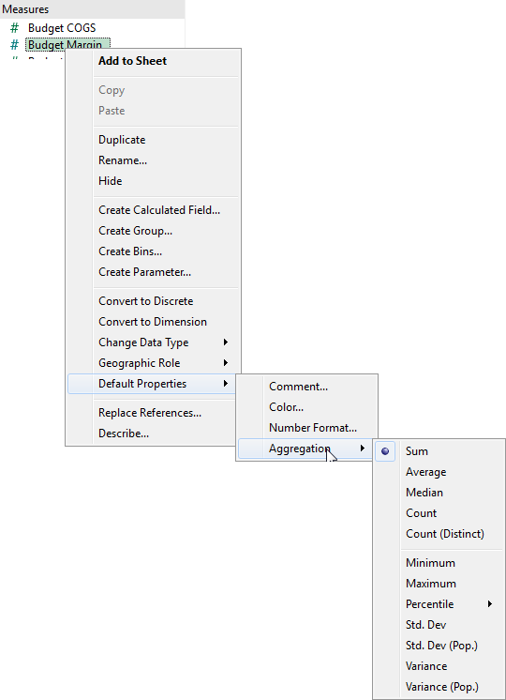

**Note**: You can use Tableau to aggregate measures only with relational data sources. Multidimensional data sources contain aggregated data only.  
  
You cannot set default aggregations for published data sources. The default aggregation is set when the data source is initially published.

## How to Disaggregate Data

Whenever you add a measure to your view, an aggregation is applied to that measure by default. This default is controlled by the **Aggregate Measures** setting in the **Analysis** menu.

If you decide you want to see all of the marks in the view at the most detailed level of granularity, you can disaggregate the view. Disaggregating your data means that Tableau will display a separate mark for every data value in every row of your data source.

**To disaggregate all measures in the view:**

* Clear the **Analysis >Aggregate Measures** option. If it is already selected, click **Aggregate Measures** once to deselect it.

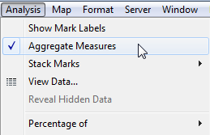

When **Aggregate Measures** is selected, Tableau will attempt to aggregate measures in the view by default. This means that it collects individual row values from your data source into a single value (which becomes a single mark) adjusted to the level of detail in your view.

The different aggregations available for a measure determine how the individual values are collected: they can be added (SUM), averaged (AVG), or set to the maximum (MAX) or minimum (MIN) value from the individual row values.

The level of detail is determined by the dimensions in your view.

Disaggregating your data can be useful for analyzing measures that you may want to use both independently and dependently in the view. For example, you may be analyzing the results from a product satisfaction survey with the Age of participants along one axis. You can aggregate the **Age** field to determine the average age of participants or disaggregate the data to determine at what age participants were most satisfied with the product.

Disaggregating data can be useful when you are viewing data as a scatter plot.

**Note:** If your data source is very large, disaggregating the data can result in a significant performance degradation.

**Example: Scatter Plots, Aggregation, and Granularity**

If you place one measure on the **Rows**shelf and another measure on the **Columns**shelf, you are asking Tableau to compare two numerical values. Typically, Tableau chooses a scatter plot as the default visualization in such cases. The initial view will most likely be single mark, showing the sum for all values for the two measures. This is because you need to increase the level of detail in the view.

### **Start building the scatter plot**

There are various ways to add detail to a basic scatter plot: **you can use dimensions to add detail**, you can add additional measures and/or dimensions to the Rows and Columns shelves to create multiple one-mark scatter plots in the view, or you can **disaggregate the data**. And, you can also use any combination of these options. This topic looks at these alternatives using the **Sample-Superstore** data source.

To create the initial view, follow these steps:

1. Place the **Sales**measure on the **Columns** shelf.
2. Place the **Profit** measure on the **Rows** shelf.

The measures are automatically aggregated as sums. The default aggregation (SUM) is indicated in the field names. The values shown in the tooltip show the sum of sales and profit values across every row in the data source.

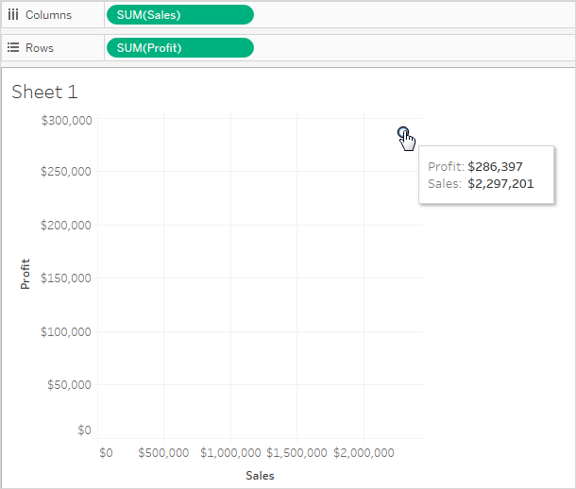

Follow the steps below to use dimensions to add detail to the view and to disaggregate data.

### **Use dimensions to add detail**

Follow these steps to develop the scatter plot view you created above by adding dimensions to show additional levels of detail.

1. Drag the **Category** dimension to **Color** on the Marks card.

This separates the data into three marks—one for each dimension member—and encodes the marks using color.

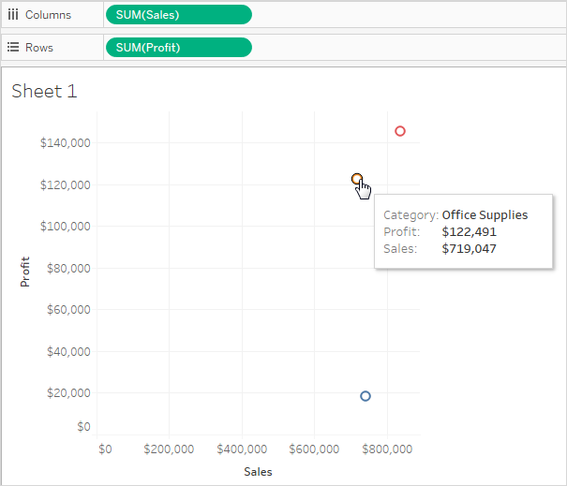

1. Drag the **State** dimension to **Detail**on the Marks card.

Now there are many more marks in the view. The number of marks is equal to the number of distinct states in the data source multiplied by the number of categories.

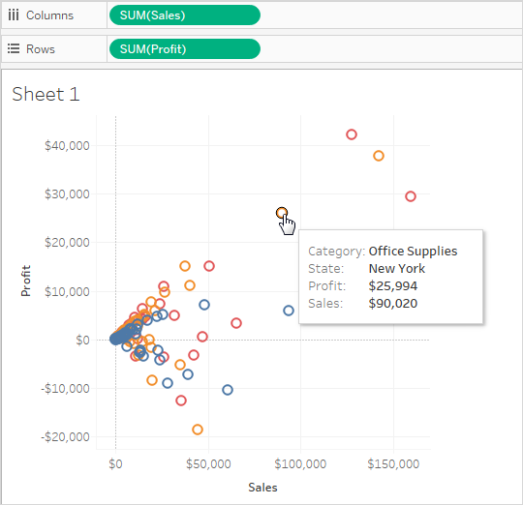

Although more marks are now displayed, the measures are still aggregated. So regardless of whether there is one row in the data source where State = North Dakota and Category= Furniture, or 100 such rows, the result is always a single mark.

Maybe this process is developing the view in a direction you find useful, or maybe you prefer to go in a different direction—for example, by adding a time dimension to the view, or by introducing trend lines or forecasting. You decide what questions to ask.

### **Try adding more fields to the rows and columns shelves**

Revert to the original one-mark view and follow these steps to develop the scatter plot view by adding fields to the **Rows**and **Columns**shelves.

1. Drag the **State** dimension to the **Columns** shelf.

Even if you drop **Continent** to the right of **SUM(Sales)**, Tableau moves it to the left of **SUM(Sales)**. This is because you cannot insert a dimension within a continuous axis. Instead, your view shows a separate axis for each member of the dimension.

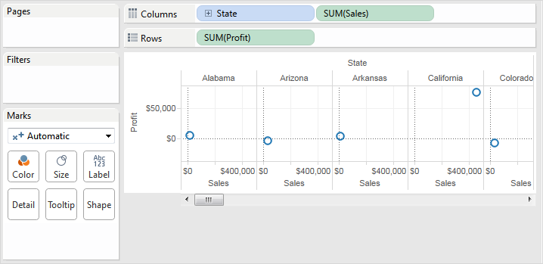

1. Drag the **Segment** dimension to the **Rows** shelf.

You now have a view that provides an overview of Sales and Profit across states and customer segments. It can be interesting to hover over the marks in the view to see tooltip data for various segments:

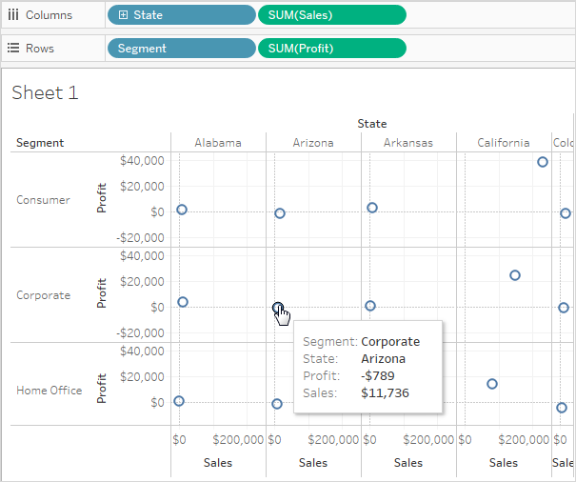

### **Try disaggregating the data**

Another way to modify your original one-mark scatter plot to display more marks is by disaggregating the data.

Clear the **Analysis >Aggregate Measures** option. If it is already selected, click **Aggregate Measures** once to deselect it.



What you have actual done is to dis-aggregate the data, because this command is a toggle that was originally selected (check mark present). Tableau aggregates data in your view by default.

Now you see a lot of marks—one for each row in your original data source:

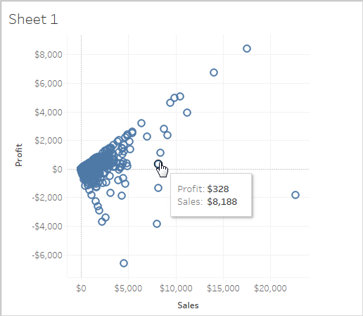

When you disaggregate measures, you no longer are looking at the average or sum for the values in the rows in the data source. Instead, the view shows a mark for every row in the data source. Disaggregating data is a way to look at the entire surface area of the data. It's a quick way to understand the shape of your data and to identify outliers. In this case, the disaggregated data shows that for many rows in the data, there is a consistent relationship between sales income and profit—this is indicated by the line of marks aligned at a forty-five degree angle.

Work with Time-series Data

1. Time series analysis is a statistical technique used to record and analyze data points over a period of time, such as daily, monthly, yearly, etc.
2. A time series chart is the graphical representation of the time series data across the interval period.
3. We can plot two or more time-series values on a single graph.

What is time series analysis?

Time series analysis is a specific way of analyzing a sequence of data points collected over an interval of time. In time series analysis, analysts record data points at consistent intervals over a set period of time rather than just recording the data points intermittently or randomly.

However, this type of analysis is not merely the act of collecting data over time. What sets time series data apart from other data is that the analysis can show how variables change over time. In other words, time is a crucial variable because it shows how the data adjusts over the course of the data points as well as the final results. It provides an additional source of information and a set order of dependencies between the data.

Time series analysis typically requires a large number of data points to ensure consistency and reliability. An extensive data set ensures you have a representative sample size and that analysis can cut through noisy data. It also ensures that any trends or patterns discovered are not outliers and can account for seasonal variance. Additionally, time series data can be used for forecasting—predicting future data based on historical data.

Why organizations use time series data analysis

Time series analysis helps organizations understand the underlying causes of trends or systemic patterns over time. Using data visualizations, business users can see seasonal trends and dig deeper into why these trends occur. With modern analytics platforms, these visualizations can go far beyond line graphs.

When organizations analyze data over consistent intervals, they can also use time series forecasting to predict the likelihood of future events. Time series forecasting is part of predictive analytics. It can show likely changes in the data, like seasonality or cyclic behavior, which provides a better understanding of data variables and helps forecast better. For example, Des Moines Public Schools analyzed five years of student achievement data to identify at-risk students and track progress over time.

Today’s technology allows us to collect massive amounts of data every day and it’s easier than ever to gather enough consistent data for comprehensive analysis.

When time series analysis is used and when it isn’t

Time series analysis is not a new study, despite technology making it easier to access. Many of the recommended texts teaching the subject’s fundamental theories and practices have been around for several decades. And the method itself is even older than that. We have been using time series analysis for thousands of years, all the way back to the ancient studies of planetary movement and navigation.

Time series analysis is used for non-stationary data—things that are constantly fluctuating over time or are affected by time. Industries like finance, retail, and economics frequently use time series analysis because currency and sales are always changing. Stock market analysis is an excellent example of time series analysis in action, especially with automated trading algorithms. Likewise, time series analysis is ideal for forecasting weather changes, helping meteorologists predict everything from tomorrow’s weather report to future years of climate change.

Examples of time series analysis in action include:

* Weather data
* Rainfall measurements
* Temperature readings
* Heart rate monitoring (EKG)
* Brain monitoring (EEG)
* Quarterly sales
* Stock prices
* Automated stock trading
* Industry forecasts
* Interest rates

Because time series analysis includes many categories or variations of data, analysts sometimes must make complex models. However, analysts can’t account for all variances, and they can’t generalize a specific model to every sample. Models that are too complex or that try to do too many things can lead to lack of fit. Lack of fit or overfitting models lead to those models not distinguishing between random error and true relationships, leaving analysis skewed and forecasts incorrect.

Classification and considerations

While time series data is data collected over time, there are different types of data that describe how and when that time data was recorded. For example:

* Time series data is data that is recorded over consistent intervals of time.
* Cross-sectional data consists of several variables recorded at the same time.
* Pooled data is a combination of both time series data and cross-sectional data.

Further, time series data can be classified into two main categories:

* **Stock time series data** means measuring attributes at a certain point in time, like a static snapshot of the information as it was.
* **Flow time series data** means measuring the activity of the attributes over a certain period, which is generally part of the total whole and makes up a portion of the results.

In time series data, variations can occur sporadically throughout the data:

* **Functional analysis** can pick out the patterns and relationships within the data to identify notable events.
* **Trend analysis** means determining consistent movement in a certain direction. There are two types of trends: deterministic, where we can find the underlying cause, and stochastic, which is random and unexplainable.
* **Seasonal variation** describes events that occur at specific and regular intervals during the course of a year. Serial dependence occurs when data points close together in time tend to be related.

Time series analysis and forecasting models must define the types of data relevant to answering the business question. Once analysts have chosen the relevant data they want to analyze, they choose what types of analysis and techniques are the best fit.

Types of time series analysis

Even within time series analysis, there are different types and models of analysis that will achieve different results.

* **Classification:** Identifies and assigns categories to the data.
* **Curve fitting:** Plots the data along a curve to study the relationships of variables within the data.
* **Descriptive analysis:** Identifies patterns in time series data, like trends, cycles, or seasonal variation.
* **Explanative analysis:** Attempts to understand the data and the relationships within it, as well as cause and effect.
* **Exploratory analysis:** Highlights the main characteristics of the time series data, usually in a visual format.
* **Forecasting:** Predicts future data. This type is based on historical trends. It uses the historical data as a model for future data, predicting scenarios that could happen along future plot points.
* **Intervention analysis:** Studies how an event can change the data.
* **Segmentation:** Splits the data into segments to show the underlying properties of the source information.

Analytics Tab in Tableau

Tableau provides a set of pre-defined functions in Analytics Tab for few data analytics tasks to be performed within Tableau, some of these functions are:

* 1. Summarise:

Set of function available in Tableau that help us in Aggregation of data.

* 1. Forecasting:

It is about predicting future value of a measure. The forecasting method used in Tableau is “Exponential Smoothening”.

* 1. Trend Lines:

Trend Lines are used to predict the continuation of a certain trend of a variable.

Apply Advanced Analysis to a View (Analytics Pane)

Drag reference lines, box plots, trend lines forecasts, and other items into your view from the **Analytics** pane, which appears on the left side of the workspace. Toggle between the **Data** pane and the **Analytics** pane by clicking the tabs at the top of the side bar.

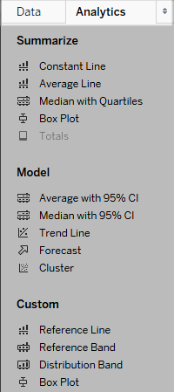

*Tableau Desktop Analytics pane*

In Tableau Desktop, options for adding Analytics objects to the view are available the **Analytics** pane or menu, or in context in the view. For example, reference lines and bands are available when you edit an axis, and trend lines and forecasts are available from the Analysis menu.

The **Analytics** pane provides drag-and-drop access for the various options.

On the web, most Analytics objects are available from the Analytics pane.

Add an analytics object to the view

To add an item from the **Analytics** pane, drag it into the view. When you drag an item from the **Analytics** pane, Tableau shows the possible destinations for that item. The range of choices varies depending on the type of item and the current view.

In a simple case, the drop target area would offer these three options:

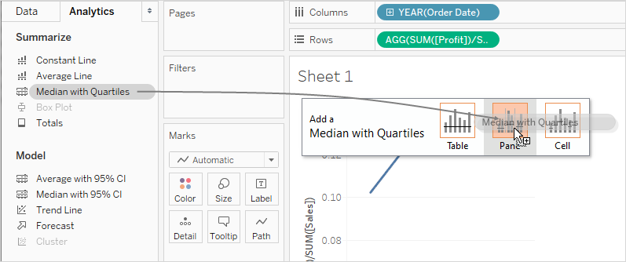

The terms **Table**, **Pane**and **Cell**define the scope for the item:

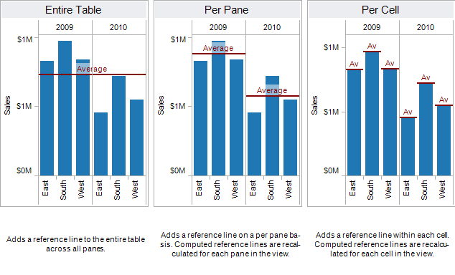

For a more complicated view—for example, if the view contained a line chart with multiple or dual axes—Tableau would show you a drop target area that looked like this:

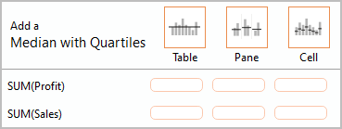

If you dropped the item in one of the three larger boxes in the header at the top of the drop target area--for example, the Table box--a separate median with quartiles would be added for each axis:

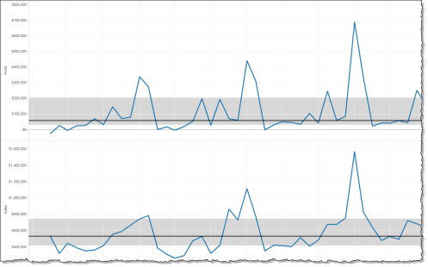

But if you drop the item in any of the six lower boxes aligned with a specific measure, the median with quartiles would only be added on the corresponding axis, with the specified scope.

Delete an analytics object from the view

You can delete an analytics object from the view by clicking Undo, or drag the object off the view to delete it.

You can also click on an item and choose **Remove** from the tooltip.

**Note**: Some **Analytics** pane items (**Median with Quartiles** and **Average with 95% CI**) add both a reference line and a reference distribution. Unless you are using Undo, you would need to delete these items separately.

Edit an analytics object in the view

To edit an item you have added from the Analytics pane, click on the item and select **Edit** from the tooltip. For additional editing options, see the section for a particular item type under Analytics object definitions, below.

Analytics object definitions

The following items can be dragged from the **Analytics** pane and dropped in the view. If an analytics object cannot be applied to the current configuration of fields in the view, it isn't available.

### **Constant Line**

Adds one or more constant lines to the view. You can add a constant line for a specific measure, for all measures, or for date dimensions. When you add a constant line, Tableau displays a Value prompt where you specify the value for the constant:



In Tableau Desktop, the Value prompt for a date value is a calendar control:

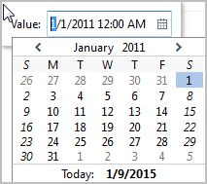

You can click on a resulting constant line and choose **Edit** or **Remove**. In Tableau Desktop there is a third option: **Format**. Choosing **Edit**opens the Edit Reference Line dialog box. Another way to edit a line in Tableau Desktop is to right-click (control-click on Mac) the relevant axis and choose **Edit Reference Line**.

### **Average Line**

Adds one or more average lines to the view. You can add an average line for a specific measure or for all measures.

You can click on a resulting average line and choose a different aggregation, such as Total or Sum. You can also choose **Edit** or **Remove**. In Tableau Desktop there is a third option: **Format**. Choosing **Edit**opens the Edit Reference Line dialog box. Another way to edit a line in Tableau Desktop is to right-click (control-click on Mac) the relevant axis and choose **Edit Reference Line**.

### **Median with Quartiles**

Adds one or more sets of median lines and distribution bands to the view. You can add a median with quartiles for a specific measure or for all measures.

The distribution bands are computed as quartiles; the middle two quartiles are shaded.

You can click on a resulting median line or distribution and choose **Edit** or **Remove**. In Tableau Desktop there is a third option: **Format**. Median lines and distributions must be edited, formatted, or removed separately. Choosing **Edit**opens the Edit Reference Line dialog box. You must click on the outer edge of a distribution band to see the options--clicking in the middle of the band has no effect. Another way to edit a line or distribution in Tableau Desktop is to right-click (control-click on Mac) the relevant axis and choose **Edit Reference Line**. A submenu will offer you two choices: **Quartiles**and **Median**.

### **Box Plot**

Adds one or more box plots to the view. You can add box plots for a specific measure or for all measures. The scope for a box plot is always **Cell**(and never **Table**or **Pane**).

Click or hover over any of the horizontal lines in the box plot to see statistical information about the whiskers, quartiles, and median.

You can also choose **Edit** or **Remove** when you click on a line. In Tableau Desktop there is a third option: **Format**. Choosing **Edit**opens the Edit Reference Line dialog box. Another way to edit a box plot in Tableau Desktop is to right-click (control-click on Mac) the relevant axis and choose **Edit Reference Line**.

**Note**: In Tableau Desktop, there are two items named **Box Plot** in the Analytics pane. For the Box Plot option in the Summarize section, Tableau will automatically add a box plot for the specified target. For the Box Plot option in the Custom section, Tableau will open the Edit Reference Line, Band, or Box dialog box after you specify a target.

### **Totals**

Adds totals to the view. When you add totals, the drop options are **Subtotals**, **Column Grand Totals**, and **Row Grand Totals**.

To remove totals, click the relevant column or row header and choose **Remove**.

In Tableau Desktop, you can also click on a totals column or row header after adding totals and set the aggregation for that row or column from the tooltip:

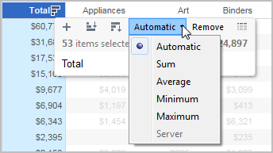

### **Average with 95% CI**

Adds one or more sets of average lines with distribution bands; the distribution bands are configured at a 95% confidence interval. You can add these items for a specific measure or for all measures.

The confidence interval distribution bands shade the region in which the population average will fall 95% of the time.

You can click on a resulting average line or distribution and choose **Edit** or **Remove**. In Tableau Desktop there is a third option: **Format**. Choosing **Edit**opens the Edit Reference Line dialog box. The average lines and distributions must be edited, formatted, or removed separately. You must click on the outer edge of a distribution band to see the options--clicking in the middle of the band has no effect. Another way to edit a line or distribution in Tableau Desktop is to right-click (control-click on Mac) the relevant axis and choose **Edit Reference Line**. A submenu will offer you two choices: **Average** and **95% Confidence Interval**.

You can also remove lines and bands by dragging them off the view.

### **Median with 95% CI**

Adds one or more sets of median lines with distribution bands; the distribution bands are configured at a 95% confidence interval. You can add these items for a specific measure or for all measures.

The confidence interval distribution bands shade the region in which the population median will fall 95% of the time.

You can click on a resulting median line or distribution and choose **Edit**, **Format**, or **Remove**. In Tableau Desktop there is a third option: **Format**. Choosing **Edit**opens the Edit Reference Line dialog box. The median lines and distributions must be edited, formatted, or removed separately. You must click on the outer edge of a distribution band to see the options--clicking in the middle of the band has no effect. Another way to edit a line or distribution in Tableau Desktop is to right-click (control-click on Mac) the relevant axis and choose **Edit Reference Line**. A submenu will offer you two choices: **Median** and **95% Confidence Interval**.

You can also remove lines and bands by dragging them off the view.

Trend Line

Adds one or more trend lines to the view. When you add trend lines, the drop options identify the trend line model types available in Tableau: **Linear**, **Logarithmic**, **Exponential**, and **Polynomial**. For some views, only a subset of these options is available.

Click on a trend line to remove or edit it, or to see a statistical definition. You can also remove a trend line by dragging it off the view.

Forecast

Adds a forecast to the view. This option is only available in Tableau Desktop—not when you edit a view on the web. Forecasting is only possible when there is at least one measure in the view.

Forecasting is not supported for views based on multidimensional data sources. In addition, the view cannot contain any of the following:

* Table calculations
* Disaggregated measures
* Percent calculations
* Grand Totals or Subtotals
* Date values with aggregation set to Exact Date

A time series containing null values also imposes constraints.

To remove, edit, or read a description of the current forecast, go to the Analysis menu and choose **Forecast**.

Custom Reference Line

You can add reference lines for a specific measure or for all measures in the view.

After you drag a reference line from the **Analytics** pane and drop it on a target, Tableau automatically opens an edit dialog box. See Add a Reference Line in the **Reference Lines, Bands, Distributions, and Boxes** article for information on the available options. To return to this dialog box later, click on the line and choose **Edit**.

Custom Reference Band

You can add reference bands for a specific measure or for all measures in the view.

After you drag a reference band from the **Analytics** pane and drop it on a target, Tableau automatically opens the Edit Reference Line, Band, or Box dialog box. See Add Reference Bands in the **Reference Lines, Bands, Distributions, and Boxes** article for information on the available options. To return to this dialog box later, click on the band and choose **Edit**. You must click on the outer edge of a reference band to see the options--clicking in the middle of the band has no effect.

Custom Distribution Band

You can add reference distributions for a specific measure or for all measures in the view.

After you drag a reference distribution from the **Analytics** pane and drop it on a target, Tableau automatically opens Edit Reference Line, Band, or Box dialog box. See Add Reference Distributions in the **Reference Lines, Bands, Distributions, and Boxes** article for information on the available options. To return to this dialog box later, click on the band and choose **Edit**. You must click on the outer edge of a distribution band to see the options--clicking in the middle of the band has no effect.

Custom Box Plot

In Tableau Desktop—but not when you edit a view on the web—you can drag a box plot from the Custom section of the **Analytics** pane and drop it on a target. (But keep in mind that on the web, you can add a box plot from the Summarize section on the Analytics pane.) When you drag Box Plot from the Custom section, Tableau automatically opens Edit Reference Line, Band, or Box dialog box. See Add a Box Plot in the **Reference Lines, Bands, Distributions, and Boxes** article for information on the available options. The scope for a box plot is always **Cell**(and never **Table**or **Pane**).

Click any of the horizontal lines in the box plot to see statistical information about the whiskers, quartiles, and median.

To return to this dialog box later, click on the band and choose **Edit**.